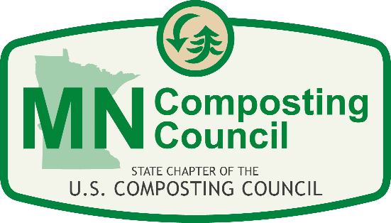
MNCC Yard Waste Compost School
Wednesday August 16, 2017
Hilton Garden Inn, Maple Grove
6350 Vinewood Lane
Maple Grove, MN 55311
Instructor | Time | Description
Ginny Black, MNCC | 8:30 am | Welcome, Course Objectives and Introductions
Tom Halbach U of MN Professor Emeritus | 8:55 am | Pre-test of Compost Knowledge and Issues
Tom Halbach U of MN Professor Emeritus | 9:20 am | History, Definitions and Composting Basics: Concepts to Remember
Tim Farnan, MPCA | 9:50 am | MN rules and regulations
Ginny Black, MNCC | 10:20 am | Break
Susie Darley-Hill, WLSSD & MNCC | 10:35 am | Organic Materials Collection and Education
Kayla Walsh, MPCA | 11:05 am | Feedstock Characteristics & Recipe Development
Katy Mutschler, MDA Monika Chandler, MDA | 11:35 am | Composting Weeds, EAB, and Gypsy Moth Infested Materials
Ginny Black, MNCC Chair | 12:05 pm | Lunch
Brad Kiecker, Komptech | 12:45 pm | Safety and Equipment
Ginny Black, MNCC | 1:15 pm | Odor Management
Kellie Kish & Ginny Black, MNCC | 1:45pm | Beyond the rules: QAP Monitoring, Testing and BMP’s
To Be Announced | 2:15 pm | Round Table: Your issues?
Ginny Black, MNCC | 2:45 pm | Break
Peter Kern, Kern Landscaping | 3:00 pm | Using compost: What is it good for?
Tom Halbach U of MN Professor Emeritus | 3:30 pm | Questions and Review: Where do we need to go next?
Ginny Black, MNCC | 3:45 pm | Adjourn
All Instructors | 3:45pm | Instructors available for questions

