RAM SWANA 17th Annual Conference & Show Post Conference Session
Co-Hosted by the Minnesota Composting Council:
Compostable Plastics & Minnesota Composting Update:
New Programs, Facilities, & Industry Advances
(6 MPCA CEUs)

Wednesday October 17th, 2012
Delano City Hall
9:00 – 3:30
Moderator: Ginny Black

Agenda:
9:00 – 9:30 Registration
9:30 – 9:45 MNCC Introduction by Board Member
9:45 – 10:30 Jim Wollschlager, Randy’s Blue Bag Organics Presentation
10:30 – 11:00 Doug Johnson, Full Circle Organics Update
11:00 – 11:15 Break
11:15 – 12:15 Dave Brooks, Biodegradable Products Institute
Past, Present, and Future of Compostable Certification
12:15 – 1:15 Lunch & Ginny Black, MN Compost Site Rule Change Update
1:15 – 2:15 Rebecca Brooks, NatureWorks LLC and Shilpa Manjure, NaturTec, Resin Distribution & Purchasing Education
2:15 – 2:30 Travel time to Randy’s Environmental Services
2:30 – 3:30 Tour of Randy’s Blue Bag Organics Program Sort Line

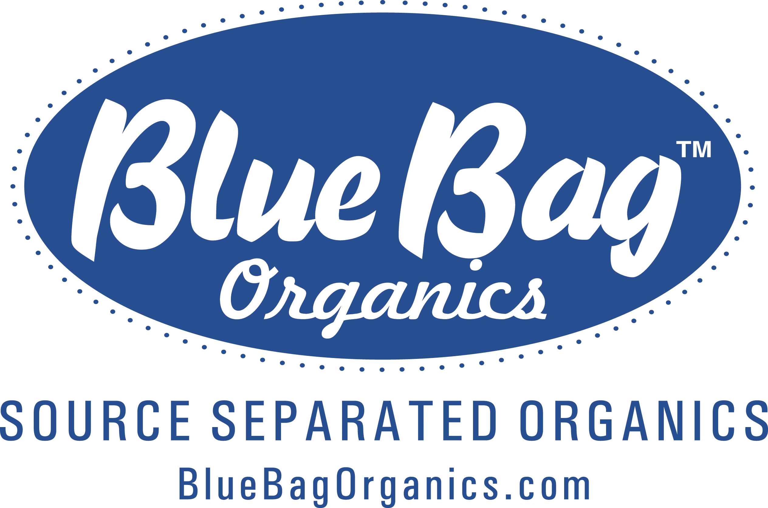
Sponsored by:
