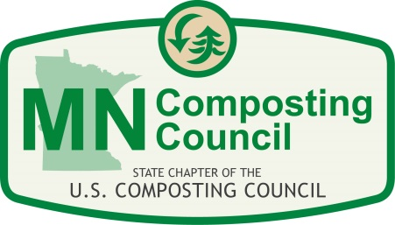
Organics Collection Programs
Summer 2017 Workshop
July 11, 2017
Stillwater KC Hall
1910 Greely Street S, Stillwater, MN 55082

AGENDA
8:30 – 9 a.m. Registration & light breakfast
9:00 – 9:10 a.m. Introduction
9:10 – 10:10 a.m. Organics drop-off programs
Speakers will discuss steps needed to open their drop-off (administrative support, permitting requirements at local level, etc.), promotion of the drop-off, participation rates, contamination issues and any surprising facts or lessons learned. Speakers include:
- Susie Darley-Hill - WLSSD
- Jane Dow and Betty Winkworth - Mankato Zero Waste
- Kellie Kish - City of Minneapolis
10:10 – 11:10 a.m. Residential organics collection programs
Speakers will discuss the establishment the program (support and approval to begin program), why the collection method was selected (including user fees), participation rates, challenges, lessons learned, and recommendations. Speakers will share what makes the program unique.
- Kala Fisher – City of St. Louis Park
- Jodi Gallup – City of Medina
- Darin Ellingson – City of Minnetonka
- Becky Kobow - City of Hutchinson
11:10 – 11:20 a.m. Break
11:20 – 12:20 p.m. Compostable products
- Emily Barker – City of St. Louis Park, Zero - Waste Packaging Ordinance
- Tim Goodman – NatureWorks, Taco Time Case Study
- Kim Lorsung - Highland Grill, Incorporating Compostable Products
12:20 a.m. – 1:00 p.m. Lunch
1:00 p.m. – 2:15 p.m. Panel of composters discussing contamination and ways to address contamination
An interactive discussion with compost facility managers regarding the types of contamination they receive at their facilities and how the deal with the issue.
  - Susie Darley-Hill – Western Lake Superior Sanitary District (WLSSD)
  - Jake Duame – Specialized Environmental Technologies (SET)
  - Mike Higgins – Midwest Recycling Solutions (MRS)
  - Erin Skelly – Shakopee Mdewakanton Sioux Community (SMSC)
  - Andy Kosek – Creekside Soils, City of Hutchinson
2:15 p.m. – 2:30 p.m. Walk to Self-Eco
2:30 p.m. – 3:45 p.m. Tour of Self-Eco - Danny Mishek (1850 Greeley St S, #300, Stillwater, MN 55082)
Target Field organics recycling - Jase Miller, Target Field
3:45 p.m. – 5:30 p.m. Networking after the tour (Location to be announced)
Thank you to our sponsors:
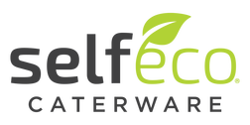
Links you might find helpful
The Value of Compostable Packaging
https://s3.amazonaws.com/gb.assets/The+Value+of+Compostable+Packaging.pdf
About the Compost Collaborative
http://greenblueorg.s3.amazonaws.com/smm/wp-content/uploads/2016/09/The-Composting-Collaborative-Presentation_Bedarf-1.pdf
Bill to allow leachate spraying to North Carolina Governor
http://www.wastedive.com/news/bill-to-allow-leachate-spraying-sent-to-north-carolina-governor/445299/
Washington State Organics Contamination Reduction Workgroup's Report and Tool Kit
https://static1.squarespace.com/static/585c2db75016e175c9d685b7/t/5936deae1b631baae4303748/1496768177591/Washington+State+Organics+Contamination+Reduction+Workgroup_FINAL.pdf
"ABC Digestate Standard Testing & Certification Program"
http://files.constantcontact.com/f7067f21401/f06dd0cf-ec65-43b3-a66b-d406593f34e1.pdf
City of Columbia Heights Plate To Garden Event
https://focus.mnsun.com/2017/05/04/chhs-key-club-hosts-fundraiser-to-encourage-composting/

